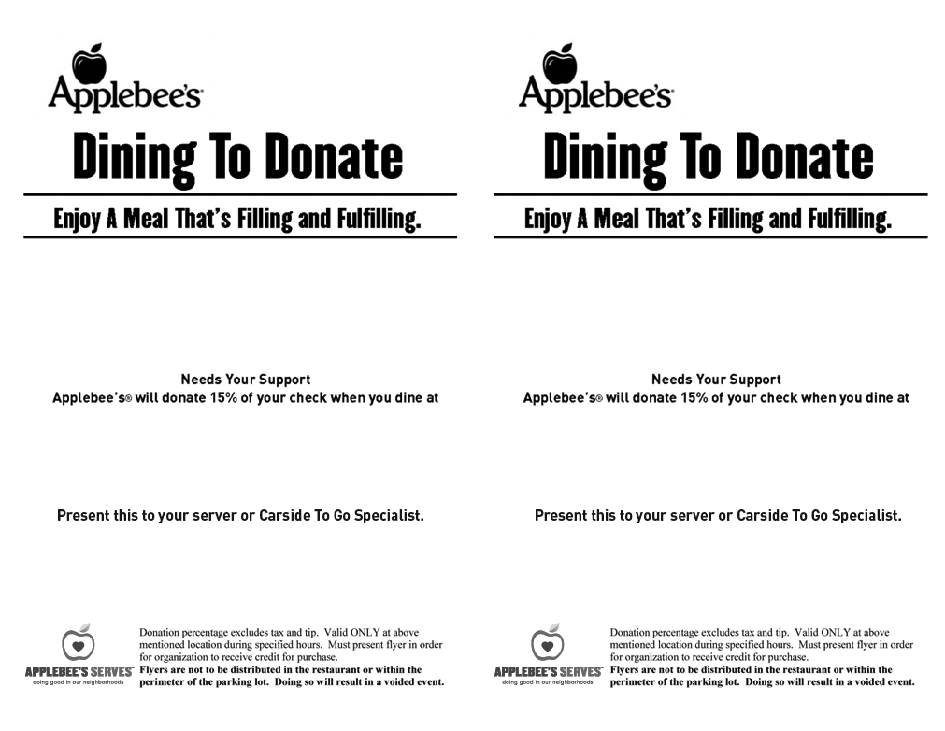

*Norwin Area Meals On Wheels*

*Norwin Area Meals On Wheels*

*Thursday, March 16*

*977 Magill Drive, North Huntingdon, PA*

**

*977 Magill Drive, North Huntingdon, PA*

*Thursday, March 16*