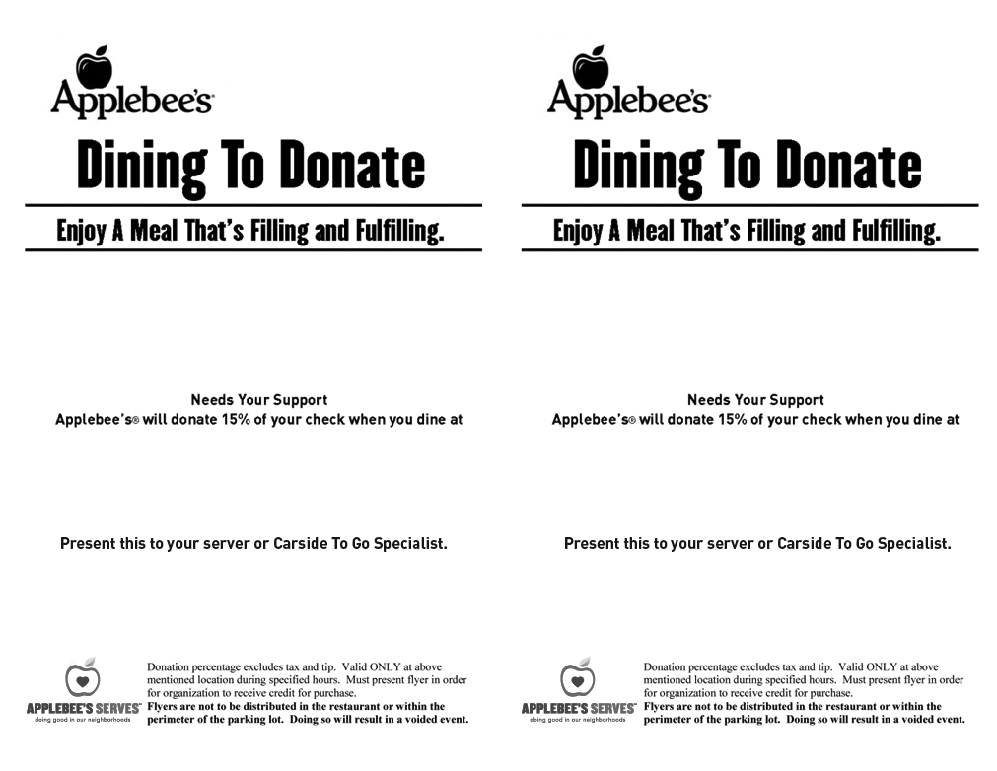

*977 MAGILL RD*

*NORTH HUNTINGDON, PA 15642*

*NORWIN AREA MEALS ON WHEELS*

*OCTOBER 19, 2017*

*977 MAGILL RD*

*NORTH HUNTINGDON, PA*

*15642*

*NORWIN AREA*

*MEALS ON WHEELS*

**

*OCTOBER 19, 2017*