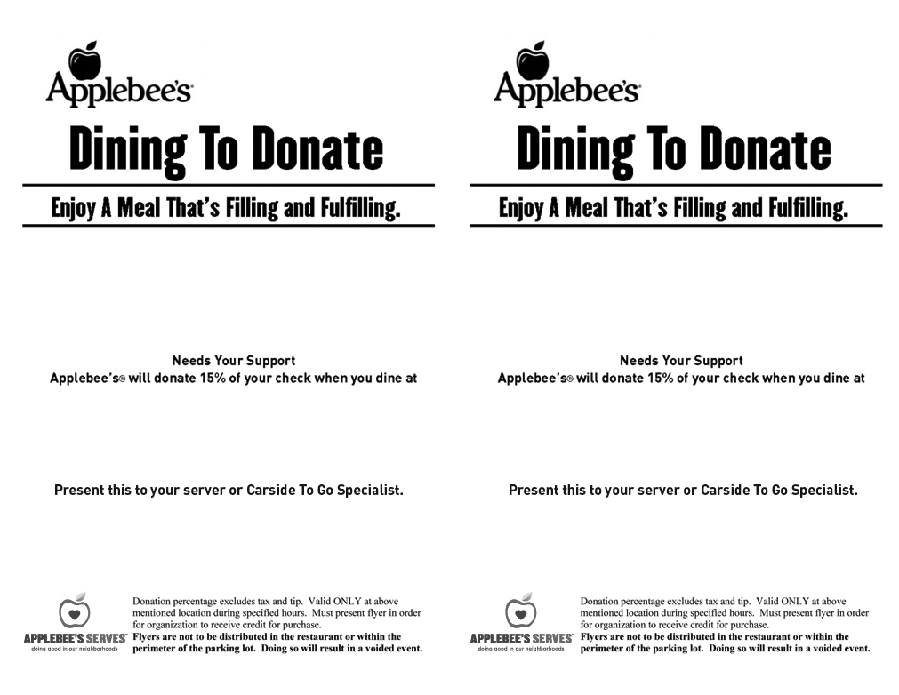

*Norwin Area Meals On Wheels*

*Norwin Area Meals On Wheels*

*Thursday, February 15, 2018*

*11am-9pm*

*977 Magill Drive*

*North Huntingdon, PA 15642*

**

*977 Magill Drive*

*North Huntingdon, PA 15642*

*Thursday, February 15, 2018*

*11am-9pm*